Module—4-Programming-structure-assignment-.r
mase
2026-02-08
# Set WD
setwd("/home/mase/Documents/LIS4370/Module 4")
################################################################################
# Dataset Key
# general doctor titled "first" (bad = 1, good = 0)
# external doctor titled "second" (bad =1 , good = 0)
# emergency unit's titled "finaldecision" (low = 0, high = 1)
################################################################################
# Load in DataSet in Vectors
Freq <- c(0.6, 0.3, 0.4, 0.4, 0.2, 0.6, 0.3, 0.4, 0.9, 0.2)
Bloodp <- c(103, 87, 32, 42, 59, 109, 78, 205, 135, 176)
First <- c(1, 1, 1, 1, 0, 0, 0, 0, NA, 1)
Second <- c(0, 0, 1, 1, 0, 0, 1, 1, 1, 1)
FinalDecision <- c(0, 1, 0, 1, 0, 1, 0, 1, 1, 1)
# Side by side boxplots
par(mfrow = c(1, 2))
# Boxplot for Frequency
boxplot(Freq, main = "Frequency Boxplot", ylab = "Frequency of Hospital Visits", col = "lightblue")
# Boxplot for Blood Pressure
boxplot(Bloodp, main = "Blood Pressure Boxplot", ylab = "Blood Pressure", col = "lightcoral")
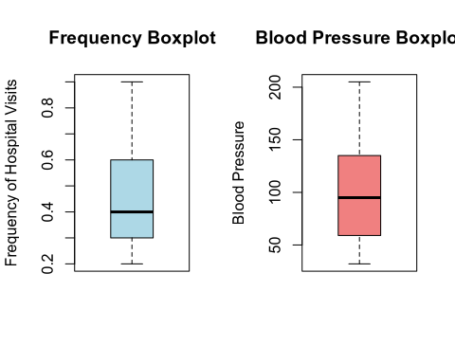
# Histogram for Frequency
hist(Freq, main = "Frequency Histogram", xlab = "Frequency of Hospital Visits",col = "lightblue")
# Histogram for Blood Pressure
hist(Bloodp, main = "Blood Pressure Histogram",xlab = "Blood Pressure",col = "lightcoral")
